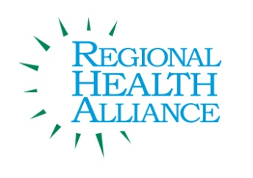

School Wellness Advisory Meeting Summary

Meeting Date: March 3, 2016

Present: Carrie Baum, Ryan Davis, Danni Heddinger, Kathy Glomski, Melinda Hautau, Jasmine Morgan, Angela Myers, Shara Jamierson, Caitlin LaValley, Glenn Noffsinger, Sherry Palmer, Laura Reynolds, Anita Riddle, Jennifer Weis, Haley Harris

Time | Agenda Item & Discussion Notes | Decisions/Next Steps
4:04 p.m. | - Welcome & Introductions
4:04 p.m. | - Review of February Meeting Minutes  - Approval of the meeting minutes.  - The motion carried.
4:05 p.m. | - Namaste Way- Using the Cafeteria as a Learning Laboratory  - Purpose:  - Today, we will discuss ways to use the Cafeteria as another teaching space to reinforce the healthy lifestyle behaviors we are trying to install in our students.  - Our Cafeteria: The Rainbow Café:  - Expectations Posted  - Social Skills and Wellness Practices reinforced through “sharing” items  - Wellness Walls  - Teaching Tools Posted  - Our Structure  - In the line for food: Info on bulletin boards, “ find the xxx”, challenges  - After receiving the food  - In the cafeteria: “shared materials”  - Eating Well Wednesdays: Tasting sessions  - Using the menu as a teaching tools  - Other curricular resources: organ wise guys, health teacher, kidshealth.org (1/week)  - Healthy Eating Habits: at least 5 servings of variety of fruits and vegetables a day, at least 3 servings of low- fat dairy, mostly whole grains, drinking at least 4 glasses of water a day  - Fresh fruit or vegetables—what nutrients help us do what?  - Salad bar option at lunch  - Fresh fruit with every meal  - 1% or skim milk served (no chocolate milk)  - Water bottles allowed  - Healthy home lunch policy  - Incentives:  - Recognizing “clean plate club”, finishing veggies or fruit  - “no thank you” bites  - “Quizzes”  - Picking the Playlist!  - Eating Well Wednesdays: Using the Menu!
4:51 p.m. | - Local Cafeteria Projects  - “Eat More Fruits and Vegetables” signs.  - Partner with Sprout for healthy/fresh produce.
5:05 p.m. | - Updates  - New Operation Fit spring posters.  - National School Breakfast Twitter competition.
5:07 p.m. | - Adjourn | Next Meeting:  Thursday, April 21st, 2016 4-5 p.m. BCCF Board Room

