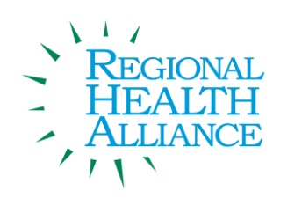

**Food Directors’ Collaborative**

**Meeting Date: 05/29/2014**

*Present: Paul Yettaw, Laura Reynolds, Deborah McDowell, Glenn Noffsinger, Jim Rutherford, Angela Myers*

|  |  |  |
| --- | --- | --- |
| Time | Agenda Item & Discussion Notes | Decisions/Next Steps |
| 2:00pm | Welcome & Introductions   * The group was made up of Pennfield, Lakeview, Marshall, Union City, Calhoun County Health Department, and RHA |  |
|  | Regional Health Alliance Overview   * Angie went over RHA and shared the organizational chart. |  |
|  | Collaborative Objectives Discussion   * The group discussed purpose and future work with the following as focus areas. * To get the districts together. * Share ideas * Share recipes * Discuss new guidelines * Report on challenges and successes * Share future trainings and events |  |
|  | Competitive Guidelines Discussion   * The group discussed the new guidelines starting in the 2014/2015 school year. |  |
|  | Future Meetings Discussion Topics/Times/Frequency   * The next meeting was scheduled for 9am, August 19th at Lakeview. |  |
|  | Next Meeting |  |
|  | Successes   * The group reported success as the following. * Taste Testing * Messaging and Branding * Union City has transitioned to Buffet Style and Grab and Go Breakfast * Lakeview now has a chef as the assistant director |  |
|  | Adjourn |  |