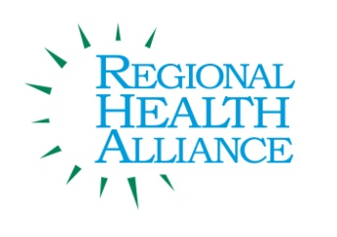 Community Dental Access Initiative Meeting Minutes
Meeting Date: July 26, 2016 Grace Health, Park Hill Meeting Room

Present: Mary Jo Byrne, Raymond Higbea (via conference call), Kathleen Langworthy, Alisha Morris, Jim Rutherford, Elizabeth Schultheiss, Dr. Steely, Barb Travis, Jennifer VanValkenburg, Briana Stuck

Time | Agenda Item & Discussion Notes | Decisions/Next Steps
8:30 | - Welcome & Introductions
8:30 | - Review of May minutes:  Motion: Minutes approved. Approved as written.
8:35 | - Dental Program Changes  - Dentists’ Partnership Program – Community Healthcare Connections announced that The Dentists’ Partnership Program will be ending on August 26, 2016. The Fountain Clinic is expanding their program to assist these patients.  - Fountain Clinic Program – The Fountain Clinic was awarded a grant through Southwest Michigan Rehab Foundation to assist in continuing and expanding their dental program. This program consists of a $5 donation for screening, cleaning and x-rays and a $25 fee for extractions and fillings. The participating dentists will bill the Fountain Clinic at 40% of their rate. The Fountain Clinic has invited dentists who participated in the Dentists Partnership Program to participate in this program.  - Other  - The Calhoun County Public Health Department is exploring establishing a dental program with Michigan Community Dental.  - Discussion on need for Community Dental Access Initiative Meetings - The majority of the group felt that the group should continue to meet regularly to educate and inform each other of new and existing programs and services that are offered.
8:50 | IV. Updates:  - Grace Health Dental Program: New dentists have started with Grace Health, which brings them to 6-7 providers daily. Albion clinic runs Monday, Wednesday and Friday from 8-5pm and is looking for dentists to join their team.  - Fountain Clinic Update: 58 total cleanings and screenings in May. 60 total cleanings and screenings in June.  - Other  - Community Action: Preparing a dental survey for families to complete as children enter school this fall and will be seeking input from the group on the draft before it is finalized.  - Goals:  - Goal #2 – Educate 500 people about the importance of oral health. This goal has been achieved.  - Goal #3 – Provide oral health education class for High School seniors. RHA is exploring options for how this goal may be achieved. |  | Jennifer VanValkenburg forwarded Community Action’s survey to the group. Suggestions to be emailed back to Kathleen Langworthy.
9:05 | V. Adjourn: |  | Next meeting:  September 27, 2016, 8:30 a.m., Grace Health

