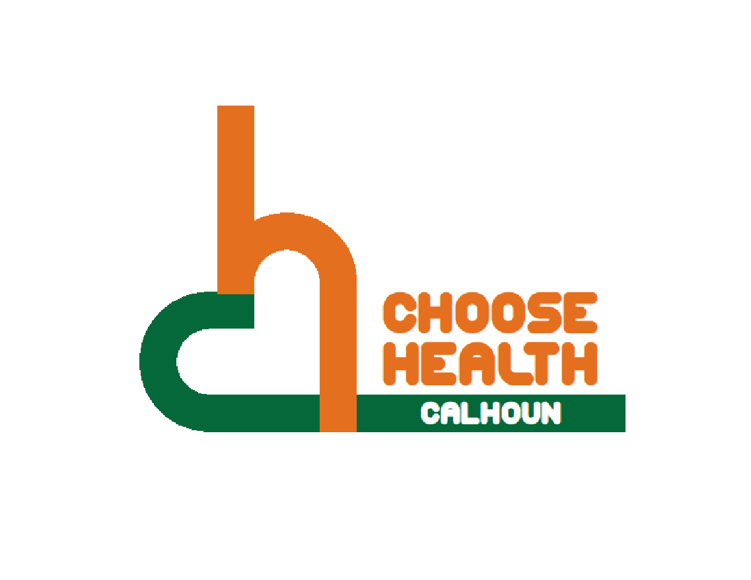
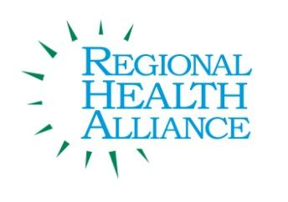
Regional Health Alliance Choose Health Calhoun Meeting Minutes
Meeting Date: 9/19/2017

Present: Duska Brumm, Eric Greene, Kathy Jarvie, Danielle Richardson, Angela Stewart, Jessica Rauch.
Time | Agenda Item & Discussion Notes | Decisions/Next Steps
10:38am | I. Call to Order & Introductions  - Ted Dearing called meeting to order.
10:42am | - Review of August 2017 Choose Health Calhoun Meeting Minutes  - Minutes were approved. Eric Greene approved and Danielle Richardson seconded.
10:43am | - Trail Work Update  - We need to look at the maps and see what fits based on our community.  - This was created for the Great Lake-to-Lake Trail.  - There are many different types of signs such as mile markers, directions, kiosk, guides, and caution such as rail road crossing and stop signs.  - If we needed to cut cost, we might only decide on certain mile markers.  - The group talked about a possibility of a trail head by the old police department with a kiosk.  - Way Finding: signs showing how far certain locations are such as how far cities are and emergency response locations. There are also symbols for food, housing, restrooms, etc.  - Other Signs: railroad crossing, non-motorized vehicles, stop signs, and way finding with other signs.  - The project locations follow the linear path (follow the river) and go from just west of Clark Road by the fort to the Emmett Street bridge.  - Group Recommendations:  - Combine 189 and 191 and place it where 191 is.  - 190- Add: Urbandale & Bedford, Grocery, Shopping, and Leila. Possible additional sign for Bedford. Local map or large map.  - 195- Add playground to Fell Park, Hiking, Biking, and Disc Golf to Leila. Add a new sign by Leila to get to Fell Park.  - 200- Possibly add Caution Seasonal Flooding sign (detour over _______).  - 240- Directional Sign for Trail.  - 260- Add Festival Market Square.  - 285- Add things like Festival Market Square and Kellogg Arena to the Kiosk. Restrooms and Visitors Bureau.  - 290- Add Caution Seasonal Flooding (detour over Michigan Ave). Make Kellogg Com to Kellogg Community College.  - 300- Make Kellogg Com to Kellogg Community College.  - 310- Add parking. Festival Sq Mkt should be Festival Market Square. Should not be Full Blast Fitness Ctr - possibly Full Blast Rec Center. Add Sponsorships?  - Between 310 and 320 add Stop signs on both sides.  - 340- No guide needed just Stop sign.  - 400- Remove the Verona Dam. What is the Sign size?  - 410- Directions sign saying to go left.  - Combine 421 and 422. Add Baily Park and Parking.  - 429- Be clear on what direction they are going. Go up to Emmet to head east and go to Bailey Park.  - We would like to add a sign on our own to the other side of Emmet. | Are the sponsorships yearly or permanently?  That has yet to be determined. I think yearly (or some other term) is a good way to pay for trail improvements or maintenance costs. The only drawback is that it requires a person or group to manage and find new sponsors. I could put you in contact with a group that uses a similar sign sponsorship program.  Are you able to see the wayfinding while on a bike or do you need to stop? Yes, the primary messaging on wayfinding signs are sized to be easily read by pedestrians and cyclists traveling at average speeds. The font used and the colors selected also support readability.  Can you add Parking, Education or Restrooms to the Way signs?  Of course :-)
11:26am | - Operation Fit Update  - Operation Fit has started the 2017-2018 school year in all 8 elementary Schools. Minges Brook, Prairieview, Riverside, Westlake, Dudley Stem, LaMora Park, Post Franklin, and Valley View.  - This year, Operation Fit has expanded their staff to 2 managers: Don Schils and Mariama Wurie, along with 4 coordinators: Emirrora Austin, Tamera Gibbs, Shayna O’Neal, and Rebecca Torres.  - All schools are currently implementing morning movement, active recess, and Operation Fit has begun to establish great relationships in the school with staff, parents, and students.  - The Operation Fit Facebook page has videos and pictures that highlights their progress so far.
11:59am | VII. Updates  - KCC- Eric Greene sat down with the KCC Foundation and athletic department representatives about the NFC proposal. As of now, there is no commitments but conversations with other possible funders.
12:03pm | VIII. Adjourn | Next Meeting:  October in the BCCF Community Room  11:00 - Noon

