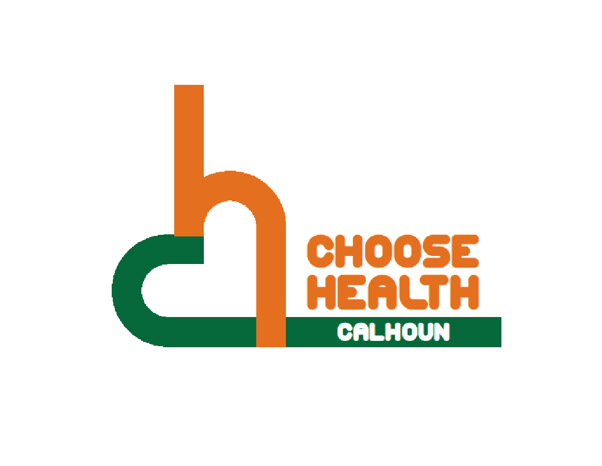

Regional Health Alliance Choose Health Calhoun Meeting Minutes
Meeting Date: 8/15/2017

Present: Duska Brumm, Eric Greene, Bill Greer, Nancy MacFarlane, Danielle Richardson, Angela Stewart, Jessica Rauch.
Time | Agenda Item & Discussion Notes | Decisions/Next Steps
11:03am | I. Call to Order & Introductions  - Bill Greer called meeting to order.
11:05am | - Review of April and June 2017 Choose Health Calhoun Meeting Minutes  - Minutes were approved. Danielle Richardson approved and Eric Greene seconded.
11:08am | - NFC Fitness Court  Phone Conferenced in Trent from National Fitness Campaign:  - Fitness courts are in over 4,000 cities.  - Fitness courts have 7 movements in 7 minutes.  - There is an app to compete against yourself and others.  - Free opportunities for people to get fit.  - Fit funding is providing money to 100 communities to find the best fit partners to launch in 2018.  - Commitment to Health and Wellness in Community look at parks and other programs.  - Finding a site to build a gym that is visible to the community.  - Funding is $90,000 plus instillation. $90,000 (Fit Radio provides $10,000, and national fitness campaign assists with finding the other $80,000 and campaign supports the process).  - 3 stages of PR: Week long featured nationally and locally with a PR kit. Building excitement for the launch (free membership to free gym) and ongoing engagement and getting community involvement.  - Timing (do not need the funds until a year from now).  - Up-keep costs and maintenance - 1 time maintenance program with less than $1,000 a year.  - Course is supposed to last for 25 years, and floor will probably be replaced around 10 years.  - Ideal locations would be at a park - there is already activity in that area and possibly along the trails. Visibility is very important - possibly along the water.  - Detroit, Saginaw, and Grand Rapids are all looking at this in their communities.  - Instructions are on walls and side and front panels about how it works with diagrams, and also on the free app.  - The group currently doesn’t see the fit court as a priority for 2018 unless another group steps forward to provide leadership. Eric said he would ask KCC leadership if a fit court would be considered as part of the renovations planned at KCC for the corner of North and Roosevelt. | Danielle will send out the sponsorship packets.
11:20am | - Workplace Wellness Best Practices  - Joint wellness committee meeting - the next one is in September. Place where organizations come together and can share what they are doing and any issues they are having. Also discussing a possible joint health fair. Meet quarterly. Danielle will bring back a report.
11:26am | V. Trail Work- Update  Updated provided by: Bob Wilson (Executive Director of Michigan Trails and Greenways)  - What are the signs Gene is currently designing for?  - We are creating a “tool kit” of signs that will support users of the Great Lake to Lake Trails. Trail managers/advocates will be able to use the designs to bring navigation and amenity information to the segments of the GLLT that they oversee.  - Gene is also working to develop programming for the Battle Creek portion of the GLLT as a sort of prototype. It will serve as a reference to planners as they implement wayfinding signage on their portions of the GLLT.  - Is anything planned to be put in Calhoun County?  - No specific programming has yet been developed outside of Battle Creek’s city limits, but the sign designs will be made available when they have been refined and finalized – which is happening now.  - What is the next step from Local Trail Managers?  - Identifying amenities and information that would be beneficial to GLLT users would be a good task to undertake now. Also identifying locations where trail information is needed – trailheads, trail junctions, areas that historically cause confusion and other points of decision are good candidates.  - Do you currently need anything from Calhoun County?  - To this point, we have received a lot of great input and are working to synthesize that information into sign designs that will serve GLLT stakeholders well. Also, the local influence on the Battle Creek programming has been great! We are very thankful to the folks who generously used their time to attend the recent meetings and offer great input.  - Here is the latest update from Gene:  - Last week, I submitted the updated sign design drawings, the sign location plan, and sign message schedule. Nancy is currently reviewing those documents. Initial pricing has come in from one fabricator. The next steps include finalizing the sign messages and creating the kiosk map artwork. Gene will get pricing out on this today.
11:59am | VII. Updates  - Announcement in Skate Park to possibly put in old JC Penny’s.  - KCC is adding 5 more sports teams (adding women’s and men’s cross county along with bowling and women’s soccer).
12:03pm | VIII. Adjourn | Next Meeting:  September 19th in the BCCF Community Room  11:00 - Noon

