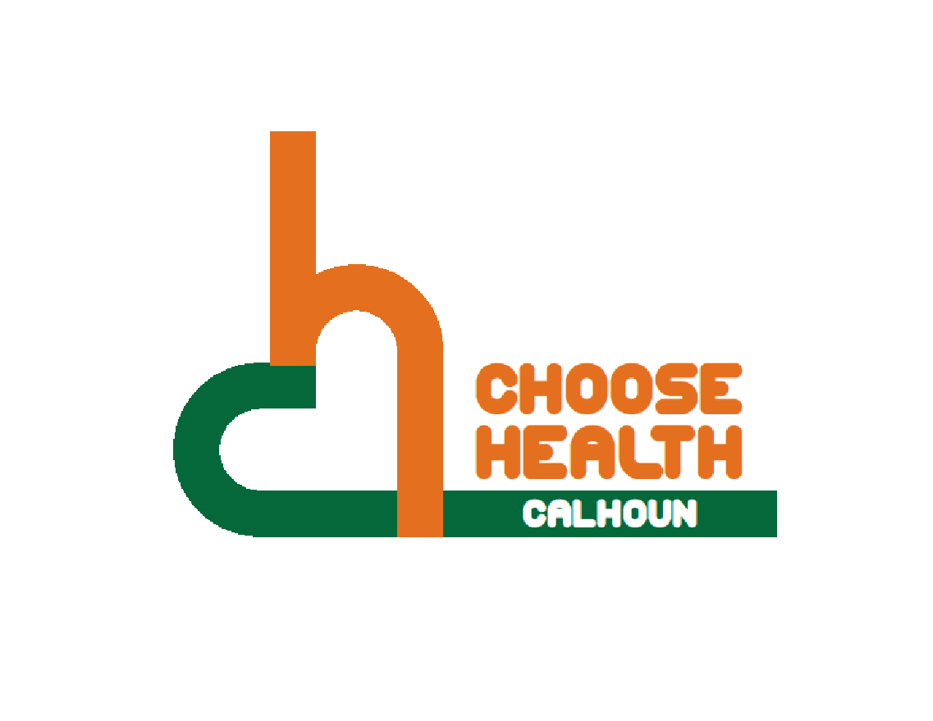

Regional Health Alliance Choose Health Calhoun Meeting Minutes
Meeting Date: 4/18/2017

Present: Bill Greer, Bre Johnson, April Kuehn, Linn Kracht, Nancy Macfarlane, Danielle Richardson, Don Schils, Angela Stewart, Jessica Rauch
Time | Agenda Item & Discussion Notes | Decisions/Next Steps
11:03am | I. Call to Order & Introductions  - Bill Greer called meeting to order.  - Introductions.
11:05am | - Review of February 2017 Choose Health Calhoun Meeting Minutes  - Minutes for February were reviewed. Approved by April Kuehn, seconded by Nancy Macfarlane.
11:06am | - Trail Work- Next Steps  - Design work has begun.  - First meeting was an informational meeting for the designer.  - They are proposing a follow up meeting to present outlines for what the signs look like and possibly where the signs go (hopefully - May 16th).  - Then a 3rd final meeting to present everything and see where there might be funding to put into the signs.  - Possibly put together an inventory (possibly pictures) of what signs are already out there. | Angie will reach out to Nancy to lay out our expectations for the next 2 meetings.
11:15am | - Workplace Wellness Awards  - We had 6 organizations apply to the 2017 Choose Health Calhoun Workplace Wellness Awards.  - The Choose Health Calhoun Workplace Wellness Award was established to recognize local companies and organizations that have outstanding workplace wellness strategies intended to promote the well-being and health of their employees.  - Each nominee completed an online survey and checked all sections that applied to their business.  - Question 2: Does your workplace have the following? (5pts)  - Question 3: Does your workplace offer the following as part of the workplace wellness plan? (4pts)  - Question 4: Does your workplace promote physical activity in any of the following ways? (15pts)  - Question 5: Does your workplace encourage healthy nutrition in the following ways? (17pts)  - Question 6: Does your workplace address disease prevention & management in the following ways? (5pts)  - Question 7: Does your workplace address tobacco use in the following ways? (7pts)  - Question 8: Does your workplace address emergency response in the following ways? (3pts)  - Each nominee is evaluated on the type, number, scope, and method of delivery of their wellness activities as well as benefits offered to their employees. We will be nominating 3 businesses that are committed to helping maintain and improve the health of their employees and have developed a great partnership to work together toward a healthier community.  - Each group member is to vote on their 3 top choices (1st- 3rd place).  - Top 3 Choices were KCC, Bronson Healthcare, and Pennfield Schools.
11:33am | V. Update on Placemaking Strategies for BC  - Culture of Vitality of BCVison decided that they need to take a step back and use a smaller scale and identify a variety of sizes and sites that they could impact in a way (example: street corners to do a few small things or to a larger location such as the linear path).  - They started off by pulling together a list of sites to start looking at and are currently finding ways to engage people in this action. They are working with BCVision Community Engagement to get people to do the initial assessment, designing, and implementing the sites. Asking them to go to the locations and identify what it looks like, what changes are needed, and what we could possibly do to improve it.  - 25 different locations of a variety of sizes and locations have been identified.  - This is going to start being communicated out to culture of vitality and the community members.  - There are groups to talk about dividing up the list of sites to take a segment of the list to assess the sites. There is some money to hold events at different sites to bring people out.  - If you would like to get involved in any of this work, please contact Angela or Ted.  - Choose Health members are willing to take time and effort to focus on place making and assist with the process. | Send the sites list out to the group.
11:51am | VI. Updates  - Trail workshop tonight at Marshall Township Office (13551 Myron Avery Dr) from Marshall to Albion.  - Vote for Operation Fit. http://act.usatoday.com/submit-an-idea/#/gallery/59700570/
11:55am | VII. Adjourn | Next Meeting:  May 16th in the BCCF Community Room  11:00 - Noon

