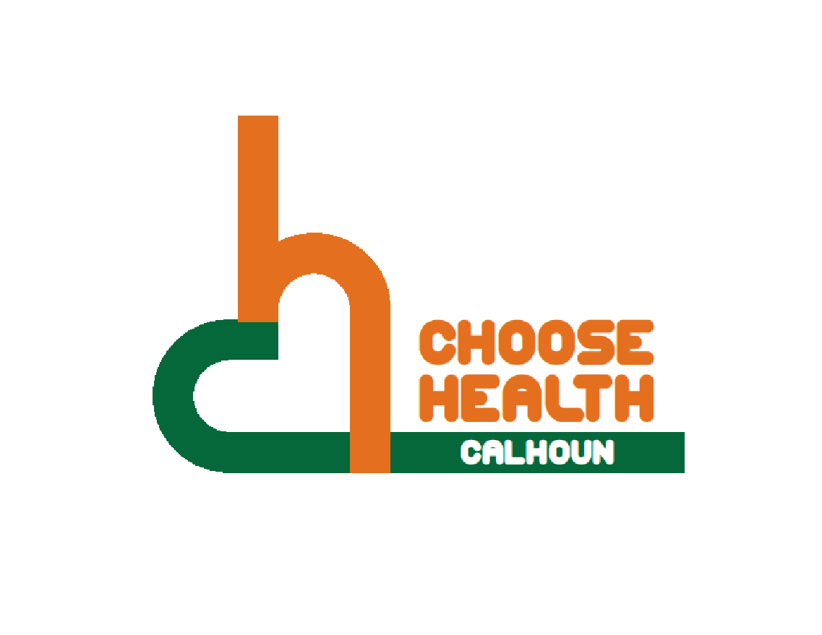

Regional Health Alliance Choose Health Calhoun Meeting Minutes
Meeting Date: 2/21/2017

Present: Michelle Datema, Eric Greene, Bill Greer, John Hart, Nancy Macfarlane, Danielle Richardson, Don Schils, Jessica Rauch
Time | Agenda Item & Discussion Notes | Decisions/Next Steps
11:05am | I. Call to Order & Introductions  - Bill Greer called meeting to order.  - Introductions.
11:05am | - Review of January 2017 Choose Health Calhoun Meeting Minutes  - Minutes for January were reviewed. Approved by Eric Greene, seconded by Danielle Richardson.
11:06am | - Small Trail Extension- Updated  - The Tribe is exploring a connection from our existing linear path on Kendall Street at the river – down to their new Fire Hub (restaurant and on the back end as a food hub and a greenhouse) location at the corner of Dickman and Kendall (the old fire house).  - On the reservation, there will also be a greenhouse to take food into school - salad bars.  - This will allow folks, for example, to bike on the linear path from the downtown to the Fire Hub site. They have provided engineering estimates, etc., and are hoping that the Tribe will move forward with this project.  - Have conceptual drawings currently done for a 2-block trail (old fire station to trail at rivers edge).  - From Kendall to Washington, it would be nice to work on this trail this summer to clean it up and show it is safe and inviting.  - Arboretum would like to do some fat tire trails. Trek would like to assist and program it to make a camping weekend with competition, night rides. Also possibly get running groups involved.  - Possibly getting options around Goguac Lake.  - We need to get a drone or camera to show the use of the trails and who and how to use it.  - In mapping or vacant lot, it would be nice to have playground or picnic tables. The city is looking at climbing statues and structures with some areas being skateable.  - Group expressed it would be nice for Leila Arboretums to have a kids’ mountain bike course.  - Currently working on the plan that should come out in the next 2 months for the master plan.
- Sign Project
- Funding is used to market for the signage. Instillation will be a different cost. They would like to use Battle Creek as a pilot.
- How do you brand the whole trail and identify the different sessions?
- It looks like we will be aiming for the first Battle Creek signage meeting around the end of March.
- We will want the people from Choose Health plus others from our list.
- The meeting will be to outline the process and the scope, show some schematic drawings, and get suggestions and answers or register concerns from the attendees.
11:20am | IV. Stakeholder Discussion  - Who Should be Involved?  - Assign Contacts -  - Miller Foundation – Linn  - Emmett Township – Linn  - Cereal City Athletics - Briana  - Chamber of Commerce - April  - Calhoun County Visitors and Convention Bureau - Eric  - Team Active - Briana  - BC Bicycle Advisory Committee - Bill  - CC Trailway Alliance - Bill  - Kalamazoo Area Runners – BC Chapter - Eric  - Friends of the Trails - KRVT- Bill  - City of BC – Danielle  - Calhoun County Government - Bill  - Calhoun County Parks Commission - Bill  - BC Unlimited - April  - Fort Custer State Park - Briana  - Chief Noonday Chapter - North Country Trail Association - Bill  - YMCA - Danielle  - Planet Fitness – Danielle  - The group agreed that the list was great, and there were no additions or subtractions. | Next steps: Get talking points from Angela and set a date and location for March or April. Once the talking points go out, group members will reach out to the organization to explain everything and invite them to the meeting.
11:44am | VI. Updates  - There is a meeting in Marshall (March 8th 4-7 at Marshall City Hall) talking about their trails.  - Albion is currently doing a lot of different parts to their trails.  - Park and Rec are hiring staff for summer.
11:47am | VII. Adjourn | Next Meeting:  March 21th in the BCCF Community Room  11:00 - Noon

