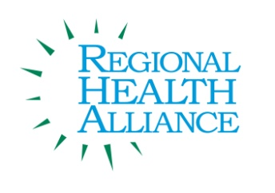
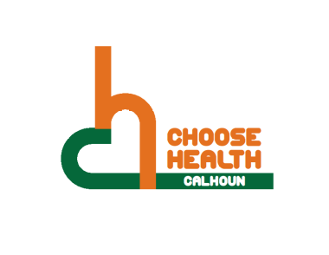

Regional Health Alliance Choose Health Calhoun Meeting Summary
Meeting Date: 12/16/2014

Present: Ted Dearing, Taylor Dreps, Bill Greer, April Kuehn, Linn D. Kracht, Angela Myers, Victoria Reese, Kristen Roux, David Tanis, Kyra Wallace, Pattie Walter, Jessica Rapelje

Time | Agenda Item & Discussion Notes | Decisions/Next Steps
11:05 a.m. | I. Call to Order  - Ted called meeting to order.
II. Approval of the Minutes
- Minutes for November 25, 2014 were reviewed. Approved by Bill Greer, seconded by Linn Kraft.

 | III. Review of Action Items/Progress  - Ted talked with the City’s planning department, and they are still early on in the process of the RFP and would like to have lot of community involvement. The City’s Planning Director Christine Zugzga is willing to come and explain everything to Choose Health in March or April.  - Novi and Muskegon have received Gold. Muskegon has done the PAC Assessment for the past 9 years, and they are moving up. Angie will be meeting with Muskegon to see what they have done to move up.  - Angela is also meeting with GSC to talk about how to get Operation Fit into the preschools and early childhood programs. | - Get a copy of the RFP.  - Put together a list of what we are advocating for when she comes.  - Kristen will email the Health Rankings.
 | IV. New Business  - RHA Leadership Retreat Overview  - Leadership Cabinet wants a better understanding of their role. They also would like more communication to the Issue Action Groups.  - Within the Regional Health Alliance, there are different Roles: Issue Action Group model, Community Champion model, and the Community Leadership model.  - There is a desire for the LC to have a better understanding of the Issue Action Groups along with having a 2 way street with communications.  - Working on building communication with Issue Action Groups and Sub Groups.  - Example: Food Directors under Choose Health.  - Talk about successes.  - Choose Health Calhoun 2014 Successes  - CHC hosted a brunch with obesity prevention expert - Genoveva Islas-Hooker to discuss community strategies.  - In collaboration with BC Chamber of Commerce, the CHC Worksite Wellness Plan was launched as a tool for employees.  - Choose Health Calhoun was highlighted on Horizon Radio.  - The BBC Feelin’ Good Mileage Club had 7 schools participate in the Battle Creek Area.  - With the help of CHC, Riverside Elementary launched their first School Wellness initiative with Birthday Books.  - CHC was invited to present on Rolling out Bikeshare at the Building MI Communities Conference.  - The first Calhoun County Food Directors Collaborative met.  - BBC Operation Fit was piloted at Valley View and Fremont Schools.  - Choose Health Calhoun completed and submitted Michigan’s Promoting Active Communities Assessment.  - Review of Action Plan/Revision Discussion  - Be a catalyst for organizations and communities to implement policies or planning projects to increase opportunities for physical activity.  - Support efforts to increase and improvements to the physical environments (i.e., parks, bike lanes, and the Linear Trail) to increase use for recreation and natural play. Specific Action: Choose Health will have representation in events similar to the Parks and Recreation survey of the community to support efforts that are consistent with Choose Health Calhoun’s objectives.  - What we might want to advocate for in 2015.  - Look into BCATS  - Look into Bikeability and Walkability.  - Identify the cities upcoming action plan and work with them.  - Address safety or perceived safety concerns that become barriers for physical activity among communities by partnering with one of the following organizations:  - Bicycle Safety, National Night Out, Walking School Bus, Local Law Enforcement, Neighborhood Watch.  - How to effectively address barriers?  - What are some of the barriers from community members? | - Angie will look into the Bikeability Audit.
 | V. Old Business  - PAC Next Steps  - Complete Street Policy’s was our biggest low.  - Walkability and Bikeability Audit were both No. This could be something for our group to advocate for.  - Regional Transportation Plan- BCATS- Focus on streets.  - Last year, our community spent 11.03% of their Michigan Transportation Fund revenues on non-motorized transportation services and facilities.  - Maintaining and increasing the amount of shared- use paths and trails. - NO?  - Planning documents - we take a lot of this into consideration, but not much of it is implemented.  - Where we lost the most amount of points - my community has already adopted a Complete Streets Policy.  - Operation Fit  - Transformed a school event that used to be baking cookies and decorating. This year instead they made snowman out of fruit and veggies.  - Working on the student wellness teams. They will lead activities in front of school or at recess.  - Poster contents for the students to take home and make it on Physical Activity and Nutrition.  - Starting in January, there will be no longer be hot Cheetos in the schools.  - Music teacher is teaming up and going to incorporate movement in his next program in the spring.  - Operation Fit was nominated at the Board Meeting for the “Above and Beyond Award.”  - After the New Year, they will be putting a peace corner in each room.  - Lead Supervisor has lost 40 pounds working with Operation Fit.  - The Staff Team at Freemont, including parents, has set up team workout nights. | - Linn will talk with Chris about BCATS.  - Review and do some research what this is and how to advocate for it:  My community has already adopted a Complete Streets Policy.
VI. Roundtable Updates
- A teacher from Riverside is working on getting more information for the application to go out for the Namaste Charter School Training.

VII. Determine Priorities/ Items for Next Meeting
- Possible January Topic Discussions:

12:04 p.m. | VIII. Adjourn | Next Meeting:  Tuesday, January 20, 2014 at 11:00 a.m.  Battle Creek Community  Foundation Boardroom

