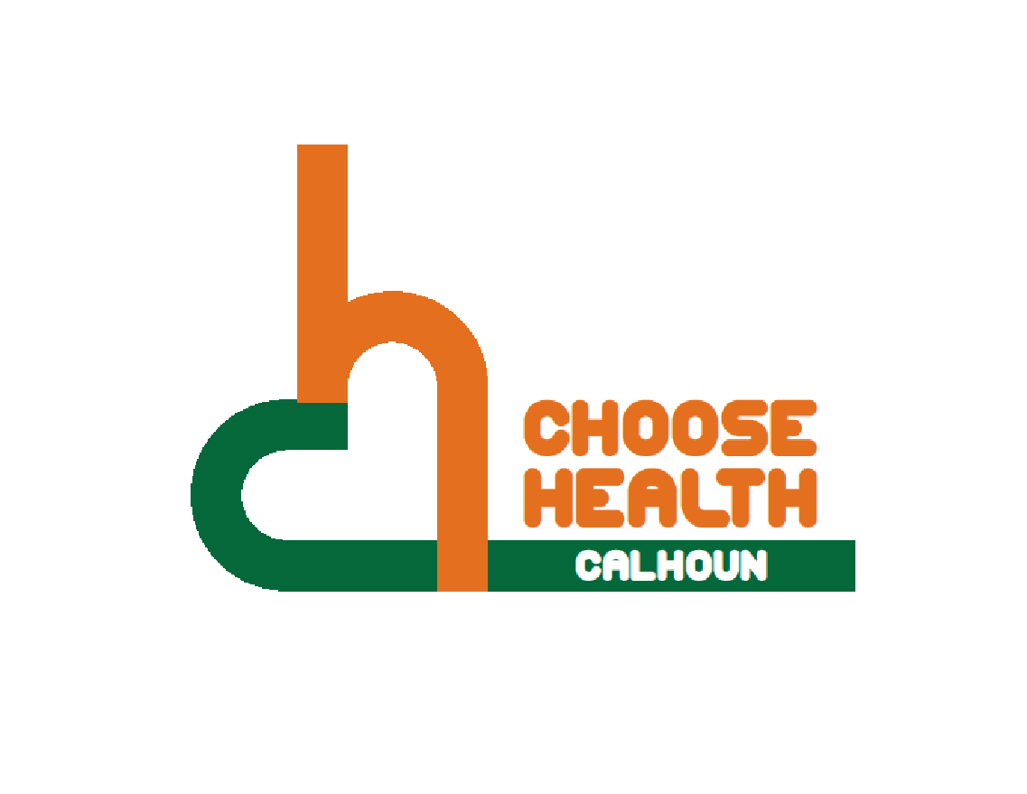

Regional Health Alliance Choose Health Calhoun Meeting Summary
Meeting Date: 11/15/16

Present: Ted Dearing, Bill Greer, Linn Kracht, Nancy MacFarlane, Terry Modert, Don Schils, Angela Stewart, Briana Stuck
Time | Agenda Item & Discussion Notes | Decisions/Next Steps
4:05p.m. | I. Call to Order  - Ted Dearing called meeting to order.
4:06p.m. | II. Purpose of Meeting  - The purpose of this meeting is continued discussion on next steps to bridge the gap from local to tourism in becoming a trail town.
4:07p.m. | III. Discussion  - Handout on “What is a Trail Town” from: http://www.liaa.org/downloads/trail_town_manual.pdf.  - Design blue print  - How often is Linear Park Trail utilized by tourists now? Mostly local.  - Gap – nothing links Linear to east and west currently.  - North Country Trails building kiosk near Math & Science Center.  - Create a parking “homebase” area downtown tom park and go from.
4:40p.m. | IV. Handout from Nancy Krupiarz. Purpose: To come up with designs and specifications for all route types of the 250+ mile Great Lake to Lake Trail from South Haven to Port Huron, MI, using the City of Battle Creek as the demonstration site.  - Nancy is looking to us to collaborate in how to connect Linear to larger trails.  - What to market this trail under when all 4 trails come together?  - Renaming Linear Park?  - Make our destination an “event” to attract tourists.  - Do we want a common trail name across all of Calhoun County?  - Signage to include the ways to each trail and local amenities.  - Funding? Nancy Krupiarz has funding and designer to create a blue print for Battle Creek and Calhoun County being the pilot.
4:58p.m. | VII. Items for Next Meeting  - Nancy Krupiarz to present at December meeting.  - Include representatives from Homer, Albion, Marshall and North Country Trails at December meeting.
5:00p.m. | VIII. Adjourn | Next Meeting:  Tuesday, December 20th, 2016, at 4:00pm  BCCF Community Room

