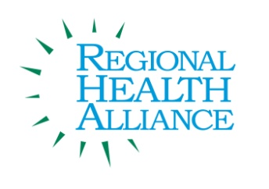
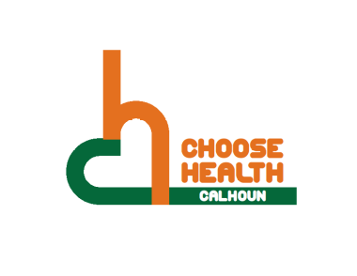

Regional Health Alliance Choose Health Calhoun Meeting Summary
Meeting Date: 1/20/2015

Present: Ted Dearing, Taylor Dreps, April Kuehn, Linn D. Kracht, Karen Manney, Angela Myers, Victoria Reese, Kristen Roux, David Tanis, Pattie Walter, Jessica Rapelje

Time | Agenda Item & Discussion Notes | Decisions/Next Steps
11:03 a.m. | I. Call to Order  - Ted called meeting to order.
11:04 a.m. | II. Approval of the Minutes  - Minutes for December 16, 2014 were reviewed. Approved by Victoria Reese, seconded by April Kuehn.
11:06 a.m. | III. Review of Action Items/Progress  - County Health Rankings were sent out after last meeting.  - Walkability and Bikeability checklists are attached. These are provided for by the EPA.  - Possible to talk about this at a future meeting to better Calhoun County PAC assessment.  - Complete Street Policy is also attached.  - Lynn Kracht had a conversation with Chris Dopp about BCATS. Every city is required to have an organization. We have BCATS who put together a 4year Transportation Plan (2014-2017) which has many projects on it for funding. They get a certain amount of funding each year, and the group sits down to determine where they want to use the funds.  - Whenever a new street is redone, if it had a bike lane, it continues. If it does not, they will add one.  - To attempt to get a sidewalk somewhere new, you have to call Chris and get on a list. They are currently trying to include South Minges and Knapp Drive.  - Last meeting, it was said 10% is used for bike lanes; but it is currently 2%, and they are trying to get that up.
11:18 a.m. | IV. New Business  - Structure of RHA  - Choose Health is a subgroup of the Regional Health Alliance.  - Currently the RHA is trying to address the top 10 Health Priorities.  - LC does not apply directives to the Community.  - Choose Heath has a workgroup under us which is the Food Directors.  - February is the next Food Directors meeting, and they will be working on putting together a summary for the Choose Health Group.  - There is also an Issue Action Group called School Wellness. This is more of what school districts are doing.  - The new structure of RHA does not affect Choose Health.  - Choose Health has an Action Plan and put out their successes often.  - There will be annual meetings where the Co-Chairs from all the Issue Action Groups will report what they are doing for others to hear.  - PAC Next Steps  - Currently in the Neighborhoods Category: 6.9 out of 21 maximum points.  - Some items are hard to work on as a committee such as supermarket, but we could bring food cart.  - We could also look at complete street policies or the walkability.  - 1 parent from Post Franklin submitted these results.  - They just report on 1 neighborhood that was below a certain median.  - 12.12 & 12.13 is where the group could help make an impact. Post has adopted the Post Franklin School and has put on activity days.  - Parks and Rec does not have much of an outreach into parks delivering programs.  - There was an ACE program that used to be in the Neighbors. There also used to be a Fun on the Run Truck and Peace in the Parks.  - BC Vision is going to come out with Action Plan about Physical Activity that potentially could tie with this group. How can we partner with other organizations that are working on these topics?  - Community Gardens are a big part of the Community.  - Does Post Franklin have the meet up feed up summer feeding program?  - YMCA is looking to partner up with Battle Creek Public Schools to incorporate Physical Activity in the Summer Feeding Programs.  - Review of Action Plan Discussion  - Grant Proposals  - The Namaste Training grant was up in. The grant would send 10-12 individuals to the Namaste School for their own training to see what it looks like on a daily basis. They will put together an Action Plan along with a follow up. This training would be more wide spread throughout the county. Reaching people through School Wellness, School Nurses, and Administrators.  - Another proposal was put in for Food Carts to be piloted at 4 different locations. There has been separate funding for the food for a year. The grant would cover the cost of the carts. Families would be able to access this twice a week all year. The Food Directors will determine what was appropriate to go on the cart and Choose Health will be evaluating the program.
11:48 a.m. | V. Old Business  - Operation Fit  - Beginning of the New Year a big Focus is to build a Student and Staff Wellness Team.  - There will be 2 to 3 students in each 3rd, 4th, and 5th grade classes to make up the Student Wellness Team. They will take on roles such as leading morning movement, take turns doing morning announcements, put up bulletin boards, and they might also do skits at assemblies.  - Staff Wellness Team will be made up of staff members along with parents who will come together to focus on a monthly activity night. They will put together themes each month such as February a Super Bowl night with different sport activities in the gym. March is St. Patrick’s theme doing a Zumba Night.  - They are still in the process of implementing the peace corner.  - Operations Fit is being used to come in and do brain breaks during down time in classrooms.  - Operation Fit currently has funding until the end of the School year. Looking at the Budget and what is remaining to fund another year at the following 2 schools. If the grant committee thinks it is successful, we could potentially add more schools.  - Would Operation Fit potentially be used in the summer or after school for walking clubs?  - A huge success is how excited the students are to be on Student Wellness Team.  - Freemont is no longer using their lunch detention room for dentition. Students have active consequences such as walking lines or movement activity. They are no longer getting these referrals in the morning. Now they are able to use the detention room for other educational lessons.  - Another huge success is the amount of volunteers that have stuck it out and are still continuing to volunteer.
VI. Roundtable Updates
- Diabetes PATH Workshop:
- Who: People with diabetes or pre-diabetes, and their family or caregivers.
- Where: FORKS Senior Center, 101 North Albion Street, Albion
- When:1:00- 3:30 p.m. Workshop begins Thursday, February 5th & runs for 6 Thursdays, thru March 12.
- Region 3B is also holding a matter of balance 6 week training.
VII. Determine Priorities/ Items for Next Meeting
- Possible February Topic Discussions
12:04 p.m. | VIII. Adjourn | Next Meeting:  Tuesday, February 17, 2015 at 11:00 a.m.  Battle Creek Community  Foundation Boardroom

