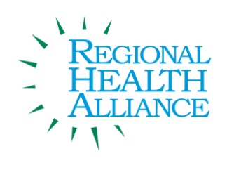
Regional Health Alliance Choose Health Calhoun Meeting Summary
Meeting Date: 08/19/2014

Present: Ted Dearing, Bill Greer, Adam Dingwall, Dave Walters, Victoria Reese, Jim Rutherford, Angela Myers
Guest: Taylor Dreps
Time | Agenda Item & Discussion Notes | Decisions/Next Steps
11:03 | Welcome & Introductions  - Ted called meeting to order.  - Minutes for April were reviewed. Approved by Adam Dingwall, seconded by Dave Walters.
Review of Action Items
- Angie reviewed the action on the next steps.
RHA Transition
- Angela went over the transition letter from Jim Rutherford.
- There were no questions at this time about the transition.
 | CHC Evaluation Discussion  - Ted shared with the group that he and Angela met with Marcus Glass the new chair of RHA.  - During the meeting it was requested CHC address evaluation of CHC.  - It was suggested to keep the macro goals in mind but look at micro level for evaluation. | - In next meeting look at individual action items.
Operation Fit Update
- Angela introduced Taylor Dreps to the group as the new Operation Fit manager.
- Angela reported to the group about a partnership with United Way and Kellogg to offer Breakfast in the Classroom.
- Angela shared with the group the updates of the program.
 | Progress on PAC Assessment  - Attendees were able to view the assessment draft report.  - Angela went over the assessment.  - It was suggested CHC continue to use the PAC assessment on a more consistent basis. | - Angela will send the final report once it is received.  - The group will review the results and discuss possibilities for improvements and future work.
Bcycle Implementation
- Angela reported the second station will be placed outside the Riverwalk building in late August or early September.
BC Chamber Worksite Wellness Update
- Angela shared the “Choosing Healthy Meals for the Workplace” document.
Roundtable Updates
- Victoria reported on receiving funding from the Fair Food Network.
- The BC Bicycle Advisory completed their assessment for the Bike Friendly Community and learned there have been 17 new actions taken toward a bike friendly community.
- There will be two new indoor bike racks implemented downtown.
- Food Director’s Collaborative August 27th.
- Linear Path is being repaved at this time.
- The Calhoun County Trail will be completed by end of September.
- IHP has been working to bring employers and physicians to talk about issues they face. They will be having their second meeting September 10th.
Determine Priorities/Items for Next Month
- Choose Health Calhoun Evaluation
11:50am | Adjourn

