**Breastfeeding Coalition of Calhoun County, Retreat, June 6, 2017**

**9:00-3:00**

**Miller Manor, Battle Creek, MI**

**Present**: Diana Buist, Michelle Datema, Rayven Felix, Stephanie Freeman, Sue Gehrman, Erika Gothberg, Angela Hart, Carrie Klein, Barbie Kryzanski, Jasmine Morgan, Cindy Standish, Jennifer VanValkenburg, Shannon McKenney Shubert

**Facilitator:** Tina Cardarelli

**Guest:** Amy Macke

**Suggested resources for Coalition to consider reading**: Community Conversations, Paul Born; Ignite! Frances Dunn Butterfoss

* Coalitions Matter: “Collective effervescence”
* Passion of the people of the Coalition has to match the projects of the group

**Passion: Members shared their personal interests, passion and/or vision for breastfeeding and when they have had the most fun in their work with the Coalition.**

Diana Buist:

* Passion/Personal interest/Vision: Drop in center for women that includes mentor program, high school student, cooking, breastfeeding; multifaceted, natural, develop relationships
* Most fun: Visit to the Nottawaseppi Band of the Huron Potawatomi

Michelle Datema:

* Passion/Personal interest/Vision: Breastfeeding in the community promoted through home visiting programs; Breastfeeding support groups
* Most fun: Big Latch On; community input and involvement at meetings

Angela Hart:

* Passion/Personal interest: Stay at home mom & work with other mom’s in the community to provide support to other mom’s
* Most fun: Big Latch On

Carrie Klein:

* Passion/Personal interest/Vision: Gets paid to do what she loves; Love helping moms and doing home visits, gives women confidence; Collaborative nature of the Coalition
* Most fun: Retreat today.

Jennifer VanValkenburg

* Passion/Personal interest/Vision: Improve the health of children; Work with hospitals; worksite initiative
* Most fun: Collaboration toward a common goal

Barbie K.

* Passion/Personal interest/Vision: Home visiting – we are missing the piece from the hospital to when mom’s get home with the baby
* Most fun: Big Latch On

Stephanie Freeman

* Passion/Personal interest/Vision: Breastfeeding clinic, home visiting & support groups; Mentor programs like Big Brothers, Big Sisters; Call mentor whenever needed for support
* Most fun: Sistah to Sistah support group; it’s making a difference

Erika Gothberg

* Passion/Personal interest/Vision: During childbirth year, have a door to door program; Breastfeeding is hard, but do-able
* Most fun: You’re Busted program; giving out aids to support breastfeeding

Susan Gehrman

* Passion/Personal interest/Vision: Halfway house, between hospital & home; Support for women breastfeeding
* Most fun: Face to face activities with mom’s & babies; the Big Latch On; Fair

Cindy

* Passion/Personal interest/Vision: Education & culture shift needed in community; More community building, breastfeeding is normal, educate in schools
* Most fun: Big Latch On; You’re Busted program; interaction with moms in the community

Shannon

* Passion/Personal interest/Vision: Passion for women’s health; Systems work, normalizing breastfeeding in the hospital, in childcare settings
* Most fun: Visiting Coalition’s around the state

Jasmine

* Passion/Personal interest/Vision: Educating moms that breastfeeding is normal
* Most fun: Seeing everyone work together

Rayven

* Passion/Personal interest/Vision: Educating African American women about breastfeeding
* Most fun: Helping with the Sistah to Sistah African American breastfeeding club

**Summary:**

* Big Latch On was community connection and was fun
* Suggestions: Look into Black Breastfeeding Coalition in Indiana; Bosom Buddy program, monthly brunch with BAMBAM
* Suggestion: Do this activity once a year and/or with new people who join to understand their interests

Who is missing from the table? Have someone from childcare or workplace to present for the first half hour of the meeting.

Suggestion: Recruit women at Big Latch On to be a part of the Coalition.

**New Vision & Mission for the BFCCC:**

Group discussed developing a new vision and mission for the group. To be considered at next meeting.

Current overarching goal: Increase breastfeeding initiation and duration rates in Calhoun County.

Objective: Empower women to overcome breastfeeding difficulties.

* Tina provided samples of other Coalition’s missions for the group to consider and shared the USBC Mission, vision, values

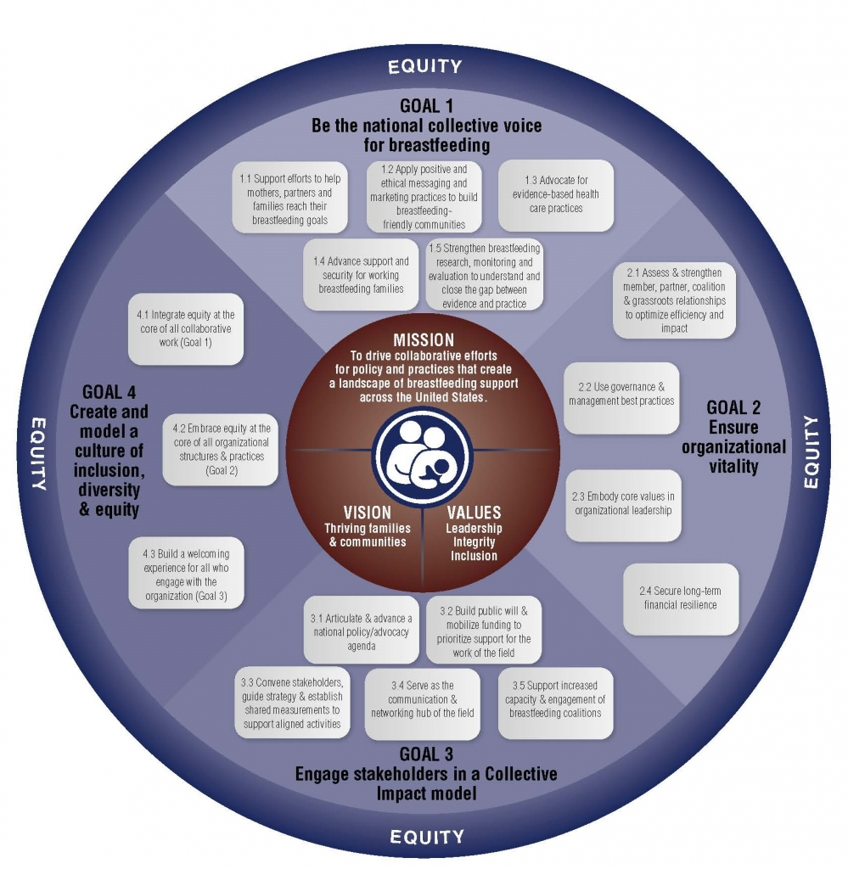

**New Structure:**

Group consensus to implement new structure, 3 co-chairs leadership approach: Health Equity Chair, Community Chair & Clinical Chair. Chairs would meet to discuss the agendas and take turns running meetings.

Meetings should include: Form, Function & Fun

**Meeting functionality**

* Review of minutes should be quick
* Small workgroups and larger group meetings – people like the flow for how the Coalition meeting schedule is currently set up
* Give 10 minutes to the new person; What brought them in the door; What do they care about in the community; Plug them in to what we’re working on, what we have done
* We are charged with tapping into people’s strengths that come to meetings

Develop a bio for everyone and include their strengths. Why are you a member? Put the new member’s bio in the minutes.

Coalition: Can develop the executive leadership

**Member Recruitment & Retention**

Recruitment for the Coalition should be in everything the group does, this is the number one priority.

**Member Retention**

* Role
* Recognition
* Rewarding
* Results
* Relationships
* Respectful of needs/wants

When someone doesn’t return to the meeting, find out why.

**Projects:** Run a back-pocket project with a long term project. i.e.: You’re Busted program with 310 Connect project. Allows for immediate gratification. Find a way to have quick wins.

**Engagement** – How do we engage our community and recruit members?

* #1 reason why people are involved in the Coalition
* Everything the Coalition does should drive people back to the Coalition; Donations; Join; Bring resources to the group
* Create an invitation to hand out inviting to meetings; Hand out at Big Latch On
* Develop sign-up sheet for people who want to join the Coalition that can be used at Big Latch On and other events
* Ask businesses for donations that were acknowledged by Coalition as breastfeeding friendly
* Idea: Great Start Collaborative Coordinator in Kalamazoo travels to businesses and drops off Anytime Anywhere clings, brings information about the law, explains why breastfeeding is important

**Components of an Elevator Speech**

1. Develop a hook; catch phrase
2. Tell who you are and what you provide in the community
3. Explain why and what you do is important
4. Ask for something
5. Wrap up what you have told them

Meeting format ideas: Meet and mingle, meet-ups, annual retreat, speakers in the community

Pair Worksite initiative with Childcare initiative. Oregon developed videos. Indiana developed “We care for Breastfed Babies”.

Develop Parking lot for ideas that you cannot act on immediately.

Dubois County Breastfeeding Coalition – If every baby born in Dubois County in 2011 was fed breastmilk for 6 months. Could be done in Battle Creek. Made it real for the community. Cost of formula and the savings.

Well babies at Walgreens; breastfeeding drop in center;

Pharmacists – CLC training; curriculum developed specifically for pharmacists.

Infrastructure building.

Build from relationships out.

Don’t stop, take the ideas further.

**Top 100 Partners Exercise Steps:**

1. Brainstorm your partner list
2. Sort your list by sector
3. Rank your list by familiarity, influence and readiness
4. Consider who to approach first
5. Craft the “ask”

**310 Connect Project** – Shannon McKenney Shubert will provide a one page summary document outlining the project that will include background on the project, intention and the deliverables of the project.

* Local Coalition provides the project, MIBFN does the work, including grant writing
* $50,000 granted for the MIBFN 310 Connect project
* Support Step 3 & Step 10 of the steps for a hospital to become baby-friendly
* Phase I. Engage your partners; Community-wide messaging around maternity care; Length = 9 months
* Deliverables:
  + Landscape Analysis
    - Identify the stakeholders
  + Networking event
  + Grand rounds done by Dr. Paula Shrek
* Will normalizing maternity care practices that lead to increased breastfeeding rates

**Follow up/homework for group:**

* Conduct 100 partner activity
* MIBFN.org/310 Connect
* Download Coffective app

**Next steps for group**:

* Mission/Vision
* 3 chair leadership
* Expanding Big Latch On