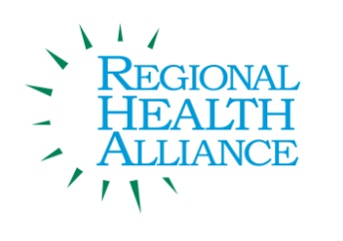

Breastfeeding Coalition of Calhoun County Meeting Minutes

Meeting Date: January 3, 2017

Present: Diana Buist, Michelle Datema, Stephanie Freeman, Sue Gehrman, Erika Gothberg, Cheryl Hinds, Rickeshia Hubbard, Barbie Kryzanski, Cindy Standish, Elizabeth Schultheiss, Jennifer VanValkenburg, Briana Stuck

Agenda Item & Discussion Notes | Decisions/Next Steps
- Welcome & Introductions: General introductions were made.
- Review of September 2016 Breastfeeding Minutes

- Review of November 2016 Breastfeeding Minutes

- Coalition Decision
- Albion Breastfeeding Club

- Workgroup Actions and Updates
- Sistah to Sistah Breastfeeding Club
- Coffective
- Worksite
- Future Workgroup Meetings
- Breastfeeding Awareness Month
- Training
- NFP Donation

- Other
- Coalition Retreat
- MIBFN Regional Coalition Meeting – September
- Updated Calhoun County Breastfeeding Resource Brochure
- Updated Meeting Calendar

- Updates
- Adjourn |  | Next meeting:  December 6, 2016, 2:00 p.m.

